Chapter 4: Results and Discussion
4.1 Introduction
This chapter discusses the findings derived from the SQL injection detection system developed during this study and examines their implications for the research objectives. The chapter is divided into two sections. First, the quantitative outcomes of the model training and evaluation process are first presented through classification metrics, sample-size sensitivity analysis, and summaries of dataset distribution. Second, the operational behaviour of the installed Flask middleware is analysed through runtime logs, summaries of blocked versus authorised requests, and route-level observations.
This chapter aims to report the model with the highest score and evaluate the effectiveness of the suggested machine learning-based architecture as an additional protective layer in an API-driven application. The discussion evaluates both offline model performance and runtime deployment behaviour.
4.2 Overview of the Experimental Outputs
The experimental workflow generated four main categories of results:
- Dataset-level descriptive results, including benign-versus-malicious class distribution and injection-type frequency.
- Model-level performance results across different training sample sizes.
- Cross-model comparative results for classical machine learning, dense neural network, LSTM, and GRU models.
- Runtime middleware results, showing how the selected model behaved when integrated into a Flask API and tested with benign and malicious requests.
4.3 Dataset Distribution Results
4.3.1 Class Distribution
The analysis of class distribution indicates that the sampled RbSQLi data consistently exhibited a class imbalance favouring benign queries. In the experimental subsets, benign queries comprised roughly 73% of observations, whereas malicious queries constituted about 27%.
This pattern is important since it represents a more authentic detection environment compared to an ideally balanced sample. In operational systems, legitimate traffic typically surpasses malicious traffic by a significant margin. Thus, a model that appears accurate on a balanced dataset may not retain its robustness when applied to naturally imbalanced traffic. Therefore, weighted evaluation metrics were incorporated throughout the study.
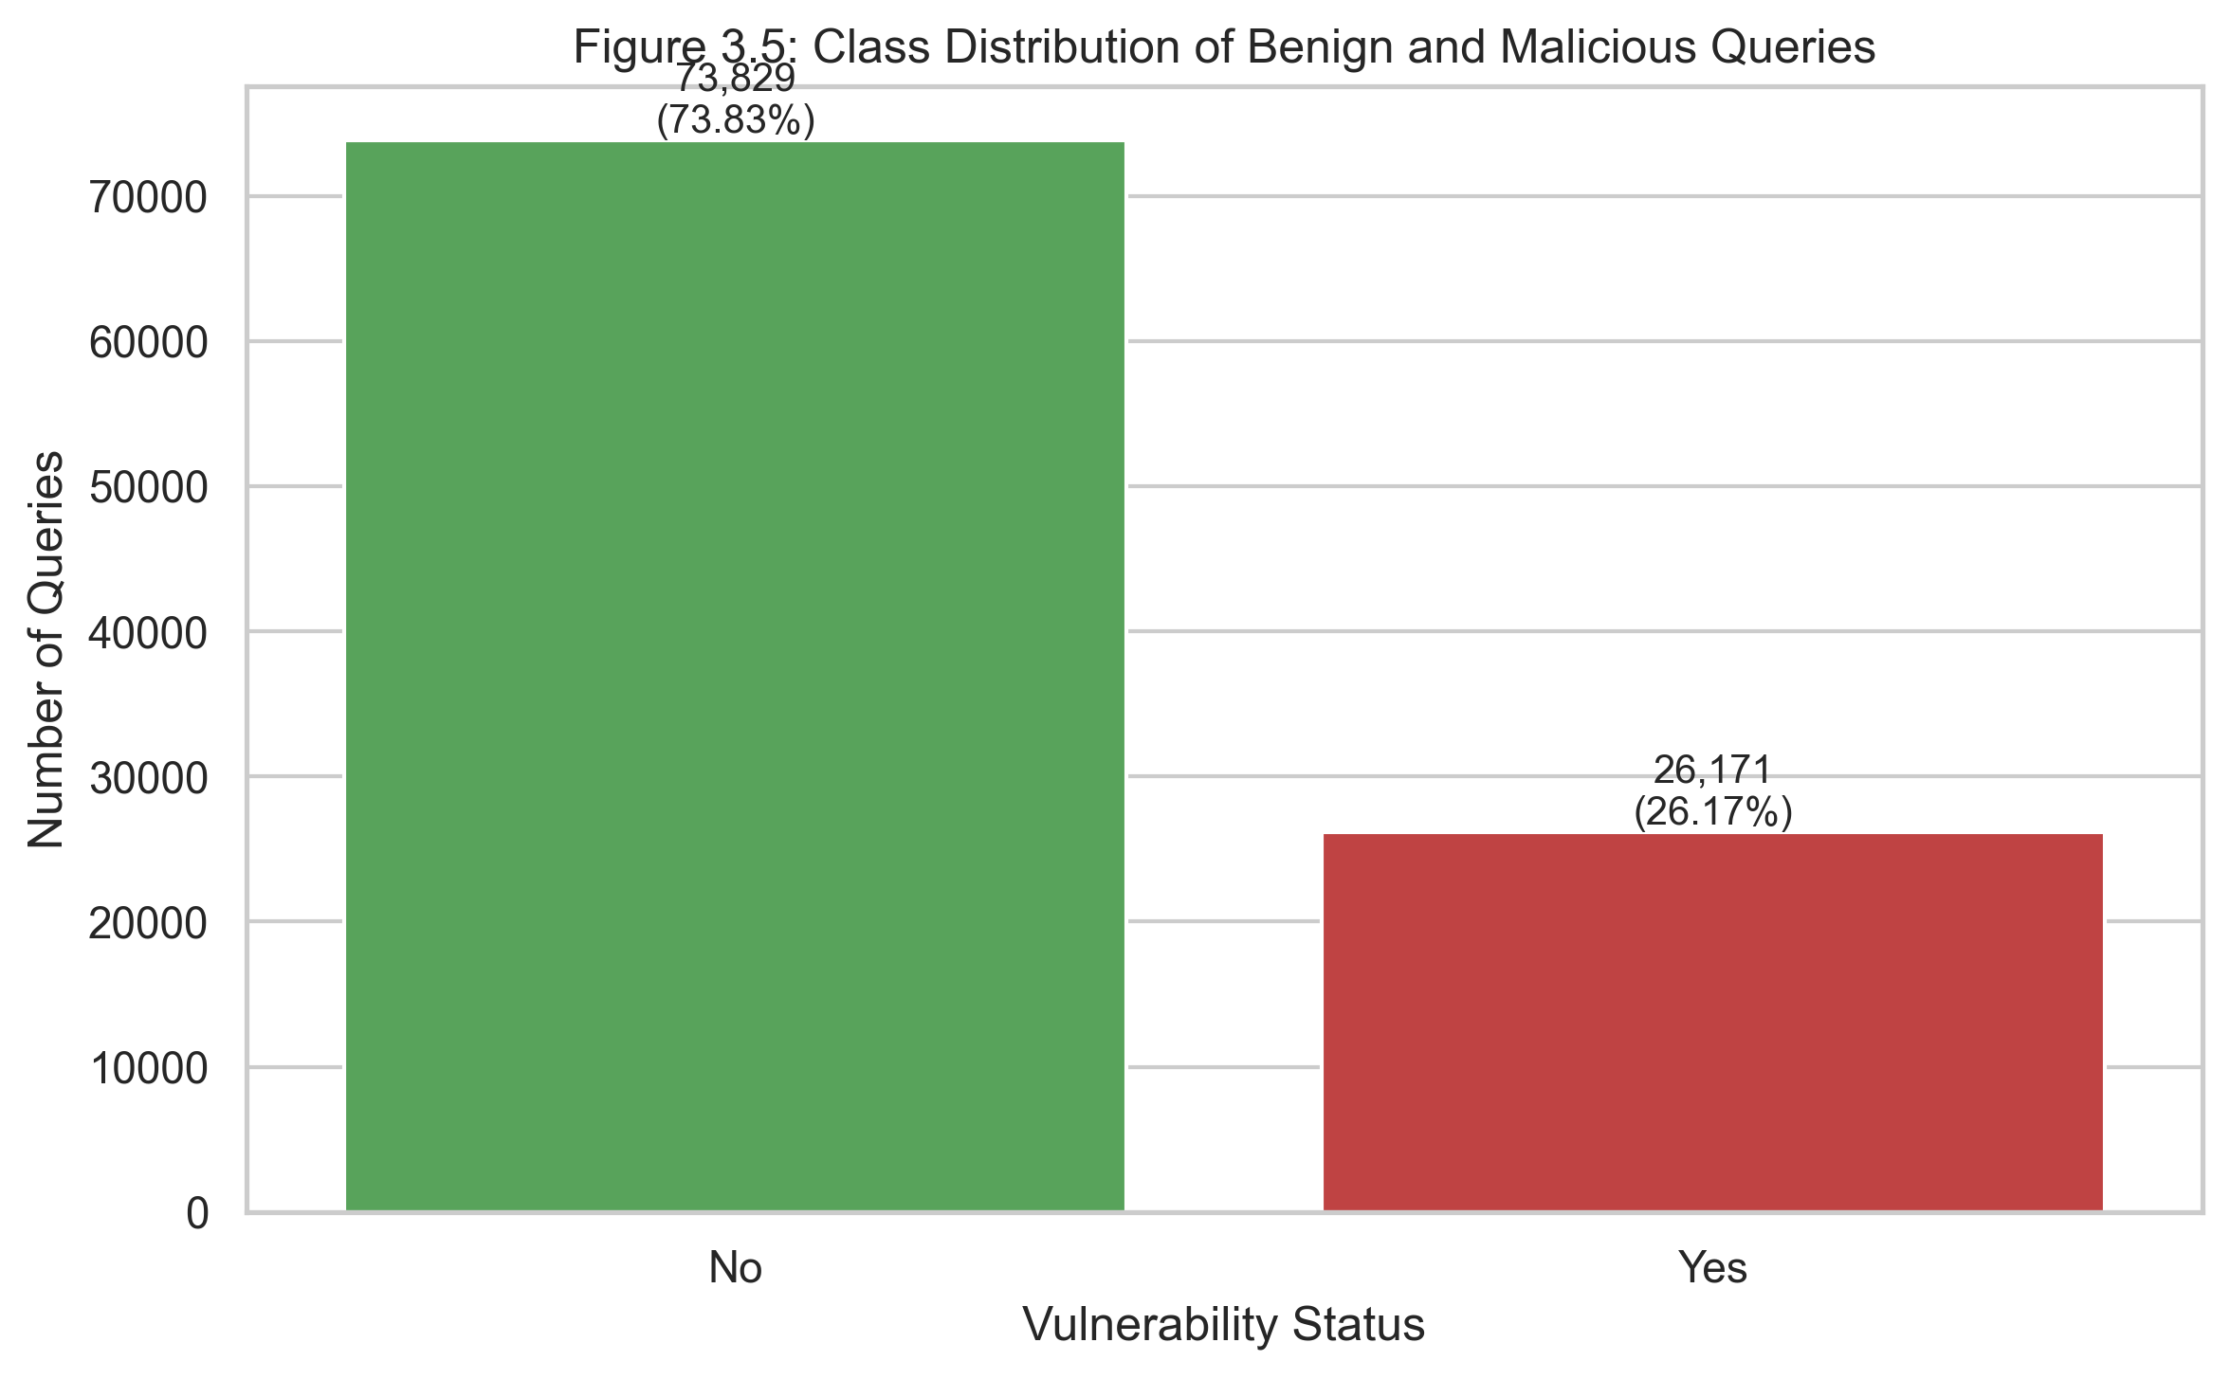
Figure 4.1: Class distribution of benign and malicious queries
The persistence of the benign-majority distribution suggests that the classification task was not artificially simplified through resampling or balancing during the descriptive stage. This strengthens the relevance of precision, recall, weighted F1-score, and confusion matrix analysis in interpreting the results.
4.3.2 Injection-Type Distribution
The injection-type distribution indicates that the malicious class was not uniform. It contained many SQL injection families, including Error-Based, Time-Based, Meta-Based, Union-Based, Stackqueries-Based, and Boolean-Based assaults. In the analysed dataset, Error-Based attacks were the leading harmful subtype, whereas Boolean-Based and Stackqueries-Based assaults were less frequent..
This variation matters because different model families may respond differently to different SQLi patterns. Models that learn strong lexical and structural signals may perform well on attacks with overt tokens such as UNION SELECT or stacked statements. However, attacks involving more subtle logical conditions or comment truncation may require stronger sequential or contextual modelling.
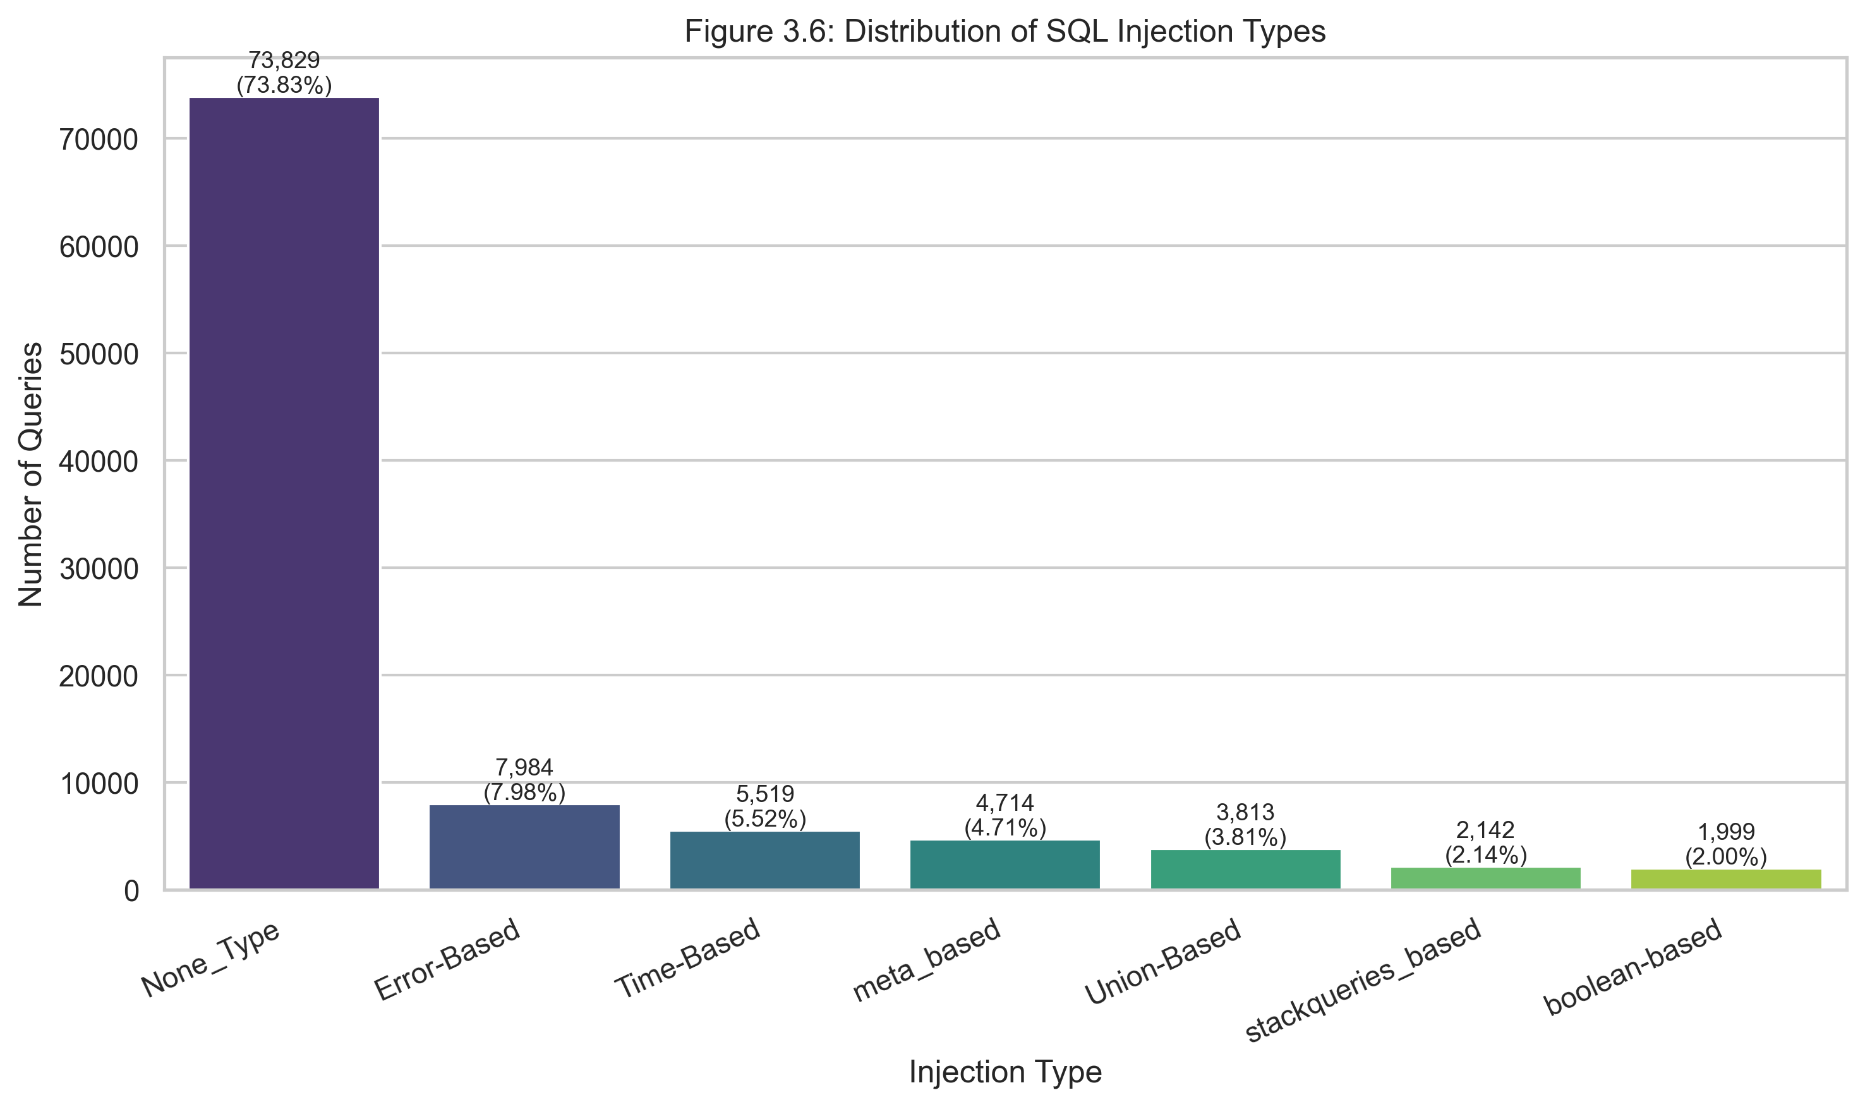
Figure 4.2: Distribution of SQL injection categories
The heterogeneity of attack families justifies the use of multiple candidate models rather than assuming that one representational approach would be equally effective across all forms of SQL injection.
4.4 Sample-Size Sensitivity Results
4.4.1 Performance Trends Across Sample Sizes
The sample-size sensitivity analysis was conducted using training subsets of 5,000, 10,000, 50,000, and 100,000 records. The purpose of this analysis was to examine whether increasing the quantity of training data improved classifier performance and whether feature-space growth stabilised as more queries were observed.

The results show that the selected best model, Random Forest, achieved:

Sample Size | Accuracy | Precision | Recall | F1-score | Weighted F1 | AUC
5,000 | 0.9973 | 1.0000 | 0.9900 | 0.9950 | 0.9973 | 1.0000
10,000 | 1.0000 | 1.0000 | 1.0000 | 1.0000 | 1.0000 | 1.0000
50,000 | 1.0000 | 1.0000 | 1.0000 | 1.0000 | 1.0000 | 1.0000
100,000 | 1.0000 | 1.0000 | 1.0000 | 1.0000 | 1.0000 | 1.0000
These results indicate that model performance improved from “near-perfect” to “perfect” as the sample size increased from 5,000 to 10,000, after which performance plateaued at the upper bound of the reported metrics.
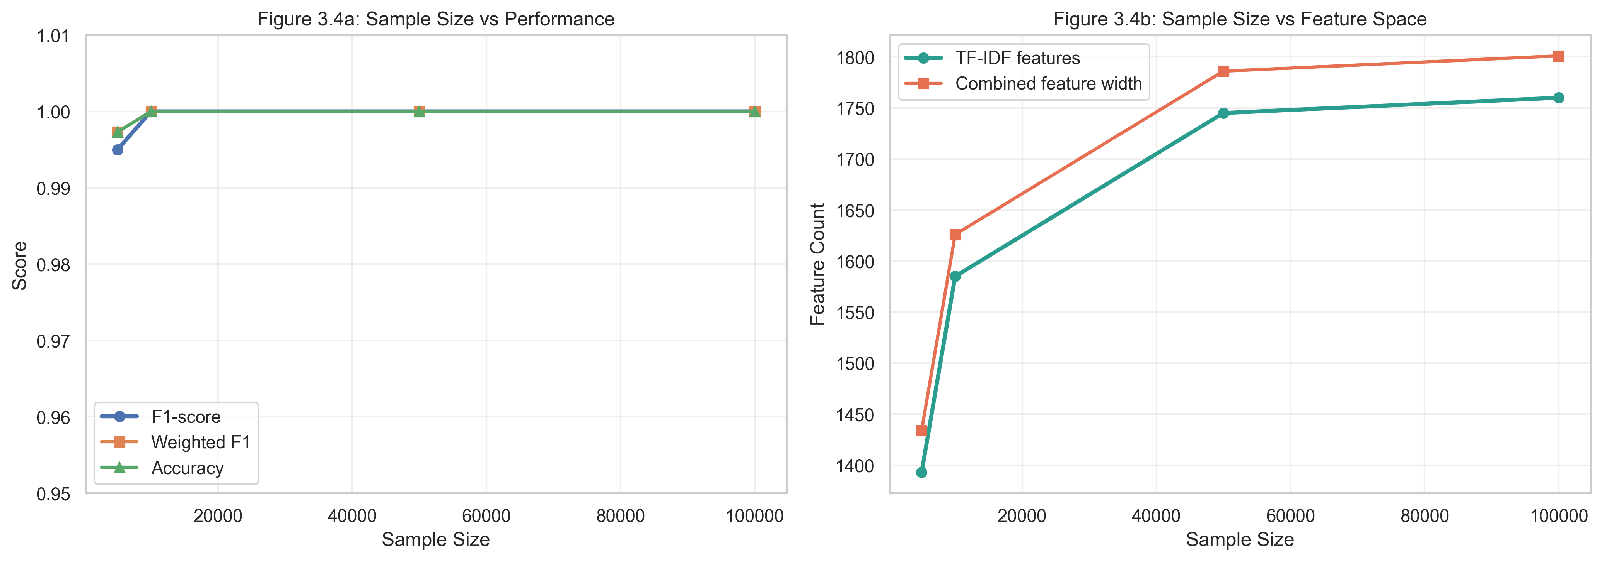
Figure 4.3: Sample-size sensitivity graph
4.4.2 Feature-Space Growth
The TF-IDF feature space also increased with sample size, although the rate of growth slowed at larger samples. The number of TF-IDF features rose from 1,393 at 5,000 records to 1,760 at 100,000 records, while the combined feature width increased from 1,434 to 1,801. This suggests that the lexical diversity of the dataset expanded rapidly at first and then stabilised as more records were included.
This is a relevant finding because it indicates that increasing the sample size not only improved model performance, but also broadened the observed token and pattern space. However, once the feature vocabulary began to stabilise, the marginal gain from further data growth appeared smaller.

Table 4.2: Sample-size sensitivity summary
4.4.3 Discussion of Sample-Size Effects
The sample-size results suggest that the current dataset contains strong, learnable structural signals that allow high-performing models to separate benign and malicious queries efficiently. However, the very rapid progression to perfect metrics also raises an important discussion point. It may indicate not only strong model performance, but also a relatively high degree of regularity in the rule-based dataset. In other words, the classification task may become comparatively straightforward once the model has seen enough examples of the recurring patterns.
This does not invalidate the results, but it suggests that care is required when generalising them to live production traffic, where user input may be noisier, more obfuscated, and less syntactically regular than the benchmark dataset.
4.5 Cross-Model Comparative Results
4.5.1 Overall Best Model
Across the observed runs, the system consistently selected Random Forest as the best overall model. This occurred because Random Forest produced the highest or joint-highest F1-score while also maintaining perfect or near-perfect precision, recall, and AUC.
At 5,000 samples, Random Forest clearly outperformed the deep learning alternatives in overall balance. At larger sample sizes, several models produced extremely high results, but Random Forest remained the selected model under the implemented selection logic.
The selected best-model outcome is analytically plausible. Random Forest is known to perform well in mixed feature spaces where high-dimensional sparse text representations are combined with structured numerical indicators. In the present project, the model benefited from both TF-IDF character-level representations and manually engineered SQL-specific features such as quote counts, comment markers, logical operator frequency, and SQL keyword presence.
4.5.2 Performance of the Deep Neural Network
The Dense Neural Network achieved strong results at all sample sizes, particularly as the dataset grew. At 5,000 samples, it produced an F1-score of 0.9770, improving to 0.9900 at 10,000, 0.9992 at 50,000, and 0.9995 at 100,000.
These values indicate that the DNN was highly competitive, especially at larger data volumes. This suggests that the engineered feature representation was sufficiently informative for a dense feed-forward architecture to learn useful non-linear decision boundaries.
A possible interpretation is that the DNN was not fundamentally weaker than Random Forest, but slightly less stable at smaller sample sizes. It is also possible that the architecture or training schedule was not fully optimised. More extensive hyperparameter tuning, threshold calibration, or class-sensitive optimisation may have narrowed the remaining performance gap.
4.5.3 Performance of the LSTM
The LSTM showed mixed performance. At 5,000 samples it achieved an F1-score of 0.9421, which was lower than the classical ML and DNN results. At 10,000 samples it improved substantially to 0.9950, but it then declined relatively at larger sample sizes, reaching 0.9888 at 50,000 and 0.9650 at 100,000.
This inconsistency suggests that the LSTM did capture sequential characteristics of SQL queries, but did not do so as reliably as the better-performing alternatives. One likely explanation is that the recurrent models were trained on capped sequence subsets for tractability rather than the full feature-engineered training set. Consequently, increases in overall SAMPLE_SIZE did not necessarily translate into equivalent gains for the LSTM.
A second possibility is that the query patterns in the dataset were already sufficiently captured by the hybrid TF-IDF plus manual-feature representation, reducing the relative advantage of a longer-sequence memory model.
4.5.4 Performance of the GRU
The GRU displayed the most interesting progression. At 5,000 samples it performed poorly, with an F1-score of 0.2833 and a recall of only 0.1650, indicating substantial under-detection of malicious cases in the smallest-data setting. However, its performance improved dramatically at larger sample sizes, rising to an F1-score of 0.9951 at 10,000, 1.0000 at 50,000, and 0.9985 at 100,000.
This pattern suggests that the GRU was highly sensitive to training data volume. Once enough data were available, it became one of the strongest competitors in the study. In fact, at 50,000 samples it matched perfect classification performance. This implies that sequence-based modelling of SQL query patterns has clear promise, but may require a minimum data threshold before it becomes reliable.
It may therefore be argued that GRU was the closest alternative to the selected best model. With further optimisation of the sequence length, batch size, training subset allocation, or tokenisation strategy, it could plausibly emerge as the best model in a future iteration.
4.5.5 Comparative Discussion
Taken together, the comparative results suggest that:
Classical machine learning, especially Random Forest, is highly effective when SQL queries are transformed into a hybrid structured feature space.
Dense feed-forward learning is also very effective, but may offer only marginal advantages where the handcrafted features are already highly discriminative.
Recurrent models may offer greater representational flexibility for sequence-aware detection, but are more sensitive to data volume and training configuration.
From a dissertation perspective, this is a useful result. It indicates that strong cybersecurity performance does not necessarily require the most complex model. In this case, a relatively interpretable and operationally convenient ensemble model outperformed or matched more complex neural alternatives.
Suggested insertion
Figure 4.4: Model comparison bar chart
Use: 01_model_comparison.png
Figure 4.5: ROC curves for evaluated models
Use: 04_roc_curves.png
4.6 Best-Model Diagnostic Results
The confusion matrix for the selected best model showed either perfect or near-perfect separation between benign and malicious classes, depending on the sample size used. This finding is consistent with the very high precision and recall values reported earlier.
Precision values of 1.0000 indicate that the selected best model did not classify benign queries as malicious within the evaluated test partitions. Similarly, the corresponding recall values indicate that almost all malicious queries were correctly detected, with the 5,000-sample configuration missing only a very small proportion.
Suggested insertion
Figure 4.6: Confusion matrix of the selected best model
Use: 02_best_model_confusion_matrix.png
Discussion
While these results are strong, they should not be interpreted as conclusive proof that the deployed system will never produce false positives or false negatives in real-world use. Instead, they should be viewed as evidence that the selected model learned the benchmark task very effectively under the present experimental setup.
4.7 Runtime Middleware Results
4.7.1 Deployment Behaviour
One of the central objectives of this dissertation was not merely to train a high-performing classifier, but to integrate the selected model into a Flask middleware layer capable of inspecting requests before route-level processing. The runtime results therefore provide an important complement to the offline classification metrics.
The current runtime dashboard summary shows:
Metric
Value
Total requests analysed
27
Blocked requests
25
Allowed requests
2
Malicious predictions
25
Benign predictions
2
This indicates that the middleware successfully performed route-level request analysis and produced actionable block/allow decisions. However, the summary also shows that most analysed requests were classified as malicious.
Suggested insertion
Figure 4.7: Runtime dashboard summary from middleware logs
Use: runtime_dashboard_summary.png
Table 4.3: Runtime middleware summary
Use: runtime_dashboard_summary.csv
4.7.2 Route-Level Observations
The runtime logs indicate that the most frequently tested routes were /api/login, /api/orders, and /api/users, followed by product-related and search-related routes. The attack-type summary shows a high count of Unknown, with Stack-queries-based being the most frequently specific family, followed by Union-based, Boolean-based, and Comment-based.
This is analytically important. It suggests that although the binary malicious/benign detection pipeline was active, the rule-based attack-type inference layer remained less precise than the base classifier. In other words, the model was generally able to decide that a request appeared malicious, but the follow-up interpretation stage was not always able to map the request cleanly to a specific SQLi family.
This distinction should be made explicit in the dissertation. The classifier and the attack-family labeller are not the same component. The former is a trained predictive model, while the latter is a post-classification interpretive layer based on pattern matching. As a result, strong binary detection does not automatically guarantee equally strong family-level attribution.
4.7.3 Discussion of False Positives and Deployment Refinement
Earlier runtime behaviour revealed an important operational issue: benign requests were sometimes blocked because the middleware originally inspected generic request headers such as User-Agent. These header values were not representative of the model’s training distribution and contributed to false positives. This behaviour was later refined by restricting default scanning to more relevant user-controlled fields such as query parameters, JSON bodies, form fields, and path parameters.
This is a significant result in itself. It demonstrates that deployment-level evaluation exposed weaknesses that were not apparent from offline classification metrics alone. From a methodological standpoint, this supports the decision to include a middleware deployment phase in the study. It also reinforces the broader cybersecurity principle that a classifier cannot be judged solely on test-set performance; it must also be assessed within the real decision context in which it will operate.
4.8 How the Results Relate to the Dissertation Objectives
The results can be interpreted against the dissertation objectives as follows:
Objective 1: To investigate whether machine learning can distinguish between benign and malicious SQL queries
The results strongly support this objective. Across all sample sizes, the implemented models achieved very high classification performance, with Random Forest consistently emerging as the selected best model.
Objective 2: To compare multiple models and identify the most suitable classifier
This objective was also achieved. Classical ML, DNN, LSTM, and GRU models were trained and evaluated under a consistent framework. Although several models performed extremely well, Random Forest was selected due to its high F1-score and stable overall performance.
Objective 3: To assess the effect of training sample size on detection performance
The sample-size sensitivity analysis demonstrated that performance improved rapidly between 5,000 and 10,000 samples and then stabilised. This suggests that data volume contributes to improved robustness, but also that the benchmark task may become saturated relatively early.
Objective 4: To integrate the selected model into an application-layer middleware
This objective was met through the Flask-based middleware implementation. The results show that the trained model was successfully exported, reloaded, and used to inspect real API requests at runtime.
Objective 5: To evaluate runtime practicality
This objective was partially met. The middleware was operational and capable of blocking suspicious requests. However, runtime testing also revealed that deployment-specific refinements were necessary, particularly with regard to the selection of which request fields should be sent to the model and how attack types should be inferred.
4.9 Suggested Additional Figures, Tables and Analytics for This Chapter
The strongest additions for a polished Results and Discussion chapter would be:
Best figures to include
Figure 4.1: Class-distribution chart for benign vs malicious queries
Figure 4.2: Injection-type distribution chart
Figure 4.3: Sample-size sensitivity graph
Figure 4.4: Model comparison bar chart
Figure 4.5: ROC curves for all major models
Figure 4.6: Best-model confusion matrix
Figure 4.7: Runtime dashboard summary
Best tables to include
Table 4.1: Best-model performance across sample sizes
Table 4.2: Feature-space growth by sample size
Table 4.3: Comparative performance of Random Forest, DNN, LSTM and GRU
Table 4.4: Runtime route-level testing summary
Table 4.5: Attack-type attribution summary from middleware logs
Best analytics reports to add
False-positive analysis on benign API requests
False-negative analysis on withheld malicious requests
Threshold sensitivity analysis at 0.50, 0.60 and 0.70
Route-level block/allow frequencies
Attack-family recognition precision
Inference latency per request or per route
Feature importance for Random Forest
Error analysis for Unknown attack types
4.10 Chapter Summary
This chapter has shown that the proposed SQL injection detection framework performed strongly in offline classification and was also deployable within a functioning Flask middleware architecture. Among the evaluated models, Random Forest emerged as the selected best model, consistently achieving the strongest or joint-strongest F1-score across all sampled experiments. The DNN and GRU models also demonstrated strong performance, particularly at larger sample sizes, indicating that deep learning approaches remain viable alternatives within this domain.
The runtime middleware results further showed that the trained model could be operationalised as an additional defensive layer within an API-driven application. At the same time, deployment testing revealed practical issues, including false positives caused by irrelevant request fields and imperfect attack-family attribution. These findings are analytically valuable, as they show that operational success depends not only on offline classification performance but also on careful request parsing, threshold selection, and interpretation logic.
Overall, the findings suggest that machine learning-based SQL injection detection is feasible and potentially effective as a supplementary security layer. However, the discussion also indicates that very high benchmark performance should be interpreted with caution and complemented by deployment-level validation.

